Delivery of Sprint-2

DEVELOP THE PYTHON SCRIPT

|  |  |
| --- | --- |
| Date | 22 Nov 2022 |
| Team ID | PNT2022TMID03634 |
| Project Name | Smart Waste Management System For Metropolitan Cities |

**TASK:**

***We can develop a python script for checking the bin’s status & publish data to IBM Cloud platform.***

**PYTHON CODE:**

#IBM Watson IOT Platform

#pip install wiotp-sdk

import wiotp.sdk.device

import time

import random

myConfig = {

"identity": {

"orgId": "4raljz",

"typeId": "newdevice",

"deviceId":"12345"

},

"auth": {

"token": "912419104033"

}

}

def myCommandCallback(cmd):

print("Message received from IBM IoT Platform: %s" %

cmd.data['command'])

m=cmd.data['command']

client = wiotp.sdk.device.DeviceClient(config=myConfig,

logHandlers=None)

client.connect()

while True:

latitude=random.uniform(27.2046,125.25)

longitude=random.uniform(77.4977,100.1526)

binlevel=random.randint(10,100)

if binlevel >= 90:

myData={'latitude':latitude,

'longitude':longitude,'binlevel':binlevel}

client.publishEvent(eventId="status",

msgFormat="json", data=myData, qos=0,

onPublish=None) ##print("Published data Successfully: %s", myData)

print("BIN IS FULL!!!!",myData)

client.commandCallback = myCommandCallback

time.sleep(2)

else :

print("BIN IS IN NORMAL LEVEL")

time.sleep(2)

client.disconnect()

**SCREENSHOTS:**

**Python program for checking the status of bin**

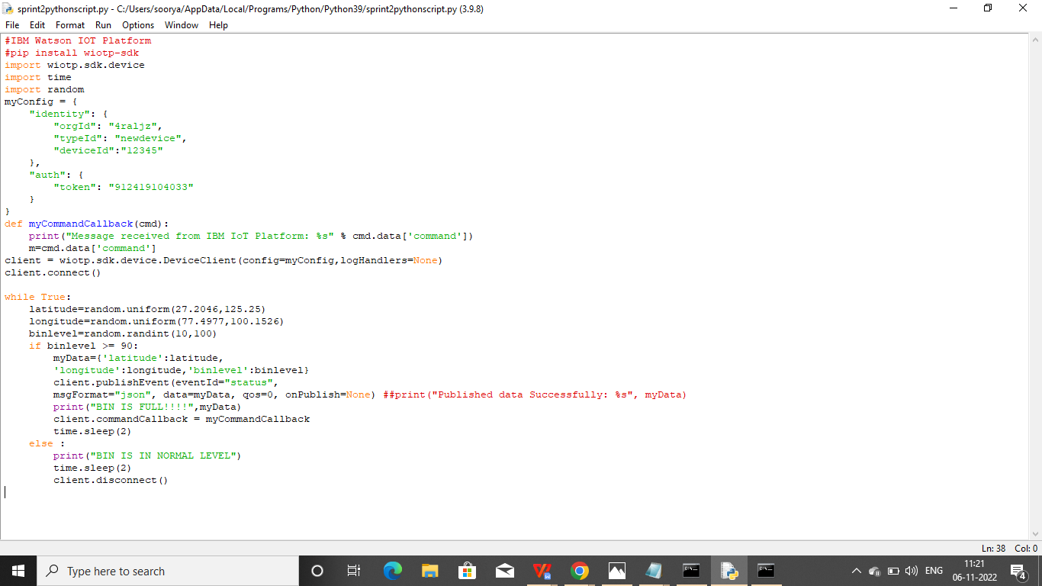

**Output**

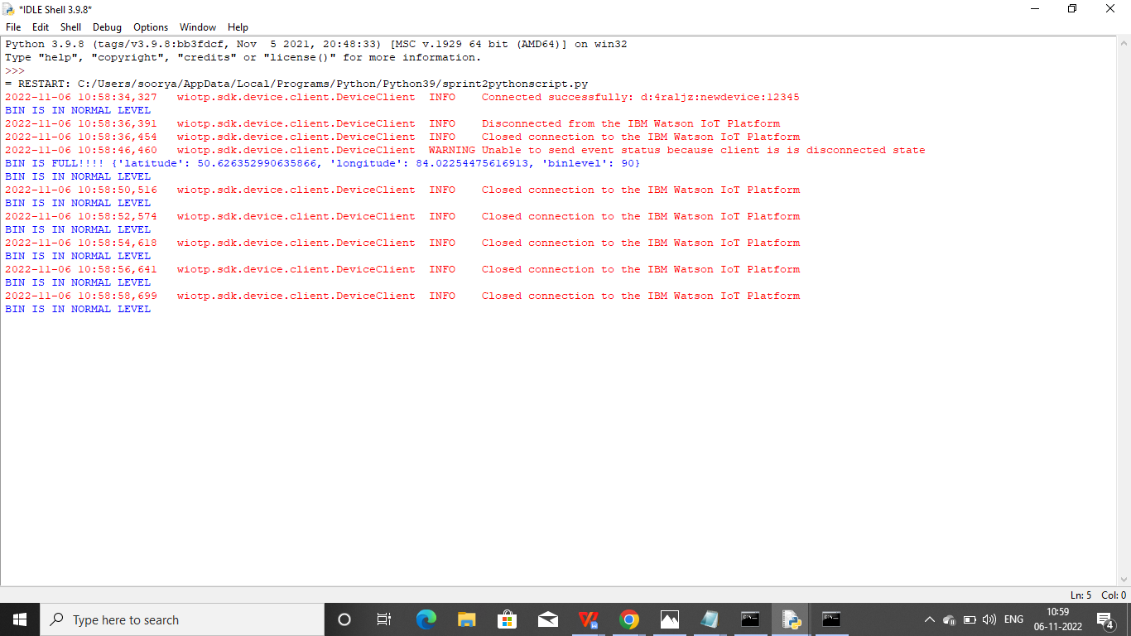

**Publish data to IBM Cloud platform**

